FAutomated ELK Stack Deployment (README FILE)
------------------------------

The files in this repository were used to configure the network depicted
below.

![TODO: Update the path with the name of your
diagram

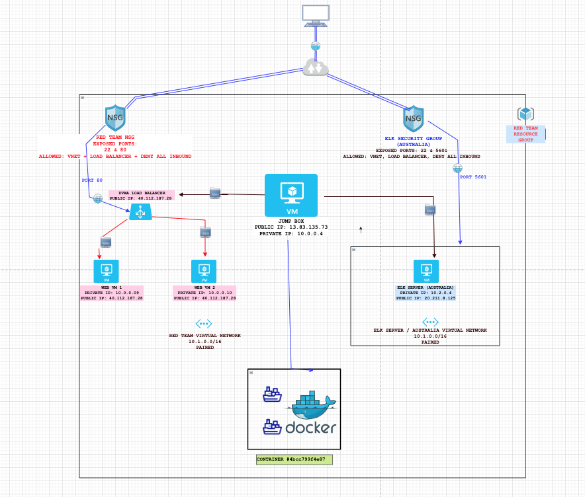

images/diagram_project 1.png

These files have been tested and used to generate a live ELK deployment
on Azure. They can be used to either recreate the entire deployment
pictured above. Alternatively, select portions of the PLAYBOOK file
may be used to install only certain pieces of it, such as Filebeat.

- *TODO: ANSIBLE-PLAYBOOK.YML & FILEBEAT-CONFIGURATION .YML FILES

This document contains the following details: - Description of the
Topologu - Access Policies - ELK Configuration - Beats in Use - Machines
Being Monitored - How to Use the Ansible Build

### Description of the Topology

The main purpose of this network is to expose a load-balanced and
monitored instance of DVWA, the D\*mn Vulnerable Web Application.

Load balancing ensures that the application will be highly ACCESSIBLE
in addition to restricting TRAFFIC to the network.

*TODO:

What aspect of security do load balancers protect? LOAD BALANCERS PROTECT AGAINST DDoS ATTACKS.

What is the advantage of a
jump box?* AN ADVANTAGE OF USING A JUMP BOX IS THAT IT IS A SINGLE POINT OF ENTRY THAT CAN BE MONITORED AND PROTECTED.

Integrating an ELK server allows users to easily monitor the vulnerable
VMs for changes to the LOGS and system TRAFFIC. -

*TODO: What
does Filebeat watch for?*FILEBEAT MONITORS CHANGES TO THE LOG FILES

- *TODO: What does Metricbeat record?* METRICBEAT ANALYSES METRICS AND STATISTICS OF THE FILES

The configuration details of each machine may be found below. *Note: Use
the [Markdown Table
Generator](http://www.tablesgenerator.com/markdown_tables) to add/remove
values from the table*.

Name Function IP Address Operating System
---------- ---------- ------------ ------------------
Jump Box Gateway 10.0.0.4 Linux
VM_01 SERVER 10.0.0.9 LINUX
VM_02 SERVER 10.0.0.10 LINUX
ELK SRVR SERVER 10.2.0.4 LINUX

### Access Policies

The machines on the internal network are not exposed to the public
Internet.

Only the JUMP BOX machine can accept connections from the Internet.
Access to this machine is only allowed from the following IP addresses: 172.117.57.160 (LOCAL MACHINE)

- *TODO: Add whitelisted IP addresses 40.112.187.28 (LOAD BALANCER)*

Machines within the network can only be accessed by PRIVATE IP ADDRESSES - *TODO:
Which machine did you allow to access your ELK VM? What was its IP
address?*

THE JUMP BOX HAS ACCESS TO THE ELK SERVER. PUBLIC IP = 20.211.8.125. PRIVATE IP = 10.2.0.4

A summary of the access policies in place can be found in the table
below.

| NAME | PUBLICLY ACCESSABLE | ALLOWED IP ADDRESSES |
JUMP BOX YES 172.117.57.160 (LOCAL)
WEB VM 1 NO 10.0.0.4
WEB VM 2 NO 10.0.0.4
ELK SERVER NO 10.0.0.4 &172.117.57.160

### Elk Configuration

Ansible was used to automate configuration of the ELK machine.

No
configuration was performed manually, which is advantageous because... -
it eliminates the possibility of HUMAN ERROR, and IT SAVES TIME BY POPULATING MULTIPLE FILES SIMULTANEOULSY.

: What is the main advantage of automating configuration with
Ansible?* THE MAIN BENEFIT OF ANSIBLE IS CONTINUITY OF DATA

The playbook implements the following tasks: - *TODO: In 3-5 bullets,
explain the steps of the ELK installation play. E.g., install Docker;
download image; etc.* - ... - ...

1 - INSTALL PYTHON3-PIP
2 - INSTALL DOCKER MODULE
3 - INCREASE VIRTUAL MEMORY
4 - USE MORE MEMORY
5 - DOWNLOAD AND LAUNCH A DOCKER ELK CONTAINER

The following screenshot displays the result of running `docker ps`
after successfully configuring the ELK instance.

### Target Machines & Beats

This ELK server is configured to monitor the following machines: -
*TODO: List the IP addresses of the machines you are monitoring*

THE ELK SERVER MONITORS ALL SERVER'S PRIVATE IP ADDRESSES

VM_01 10.0.0.9

VM_02 10.0.0.10

JUMP BOX 10.0.0.4

We have installed the following Beats on these machines: -

VM_01 10.0.0.9

VM_02 10.0.0.10

JUMP BOX 10.0.0.4

*TODO:
Specify which Beats you successfully installed*

FILEBEAT AND METRICBEAT WERE SUCCESSFULLY INSTALLED.

These Beats allow us to collect the following information from each
machine: - *TODO: In 1-2 sentences, explain what kind of data each beat
collects, and provide 1 example of what you expect to see. E.g.,
`Winlogbeat` collects Windows logs, which we use to track user logon
events, etc.*

FILEBEAT COLLECTS CHANGES TO LOG FILES

METRICBEAT COLLECTS METRICS & STATISTICS FROM THE OPERATING SYSTEM.

### Using the Playbook

In order to use the playbook, you will need to have an Ansible control
node already configured. Assuming you have such a control node
provisioned:

SSH into the control node and follow the steps below: - Copy the
elk_install.yml file to etc/ansible/roles/elk_install.yml. - Update the HOST file to
include attributes.. - Run the playbook, and navigate to http:20.211.8.125:5601/app/kibana to check that
the installation worked as expected.

*TODO: Answer the following questions to fill in the blanks:* -

*Which
file is the playbook? FILEBEAT-CONFIGURATION.YML

Where do you copy it?* /ETC/ANSIBLE/HOSTS/FILES

- *Which file do you update to make Ansible run the playbook on a specific machine? FILEBEAT-PLAYBOOK.YML

How do I specify
which machine to install the ELK server on versus which to install
Filebeat on?*THE INSTALL-ELK.YML FILE DICTATES INSTALLMENT DIRECTIONS.

Which URL do you navigate to in order to check that
the ELK server is running? http://20.211.8.125

